The Spotify Hit Predictor

A Project Submitted

in Partial Fulfillment of the Requirements

By

# Abhishek J.N

# Bachelor In Eletrical and Electronics Engineering

On

# 14-11-2020

**Preface**

Can an algorithm predict hit songs? Let’s explore how we can successfully build a hit song classifier using only audio features,

**Dataset details**

## Key Points :

* This is a dataset consisting of features for tracks fetched using Spotify's Web API.
* The tracks are labeled '1' or '0' ('Hit' or 'Flop') depending on some criteria of the author.
* **This dataset can be used to make a classification model that predicts whether a track would be a 'Hit' or not.**
* (Note: The author does not objectively considers a track inferior, bad or a failure if its labeled 'Flop'. 'Flop' here merely implies that it is a track that probably could not be considered popular in the mainstream.)

The author's condition of a track being 'flop' is as follows:

* The track must not appear in the 'hit' list of that decade.
* The track's artist must not appear in the 'hit' list of that decade.
* The track must belong to a genre that could be considered non-mainstream and / or avant-garde.
* The track's genre must not have a song in the 'hit' list.
* The genre list for the particular decades are as follows:
* The track must have 'US' as one of its markets.

**Analysis**

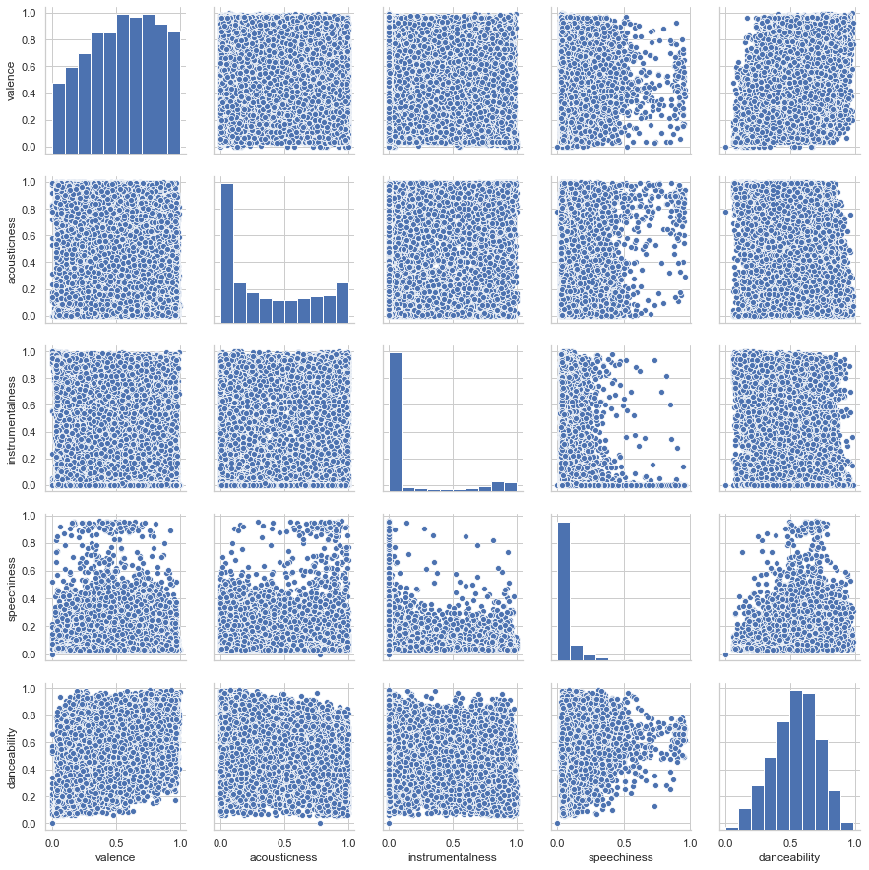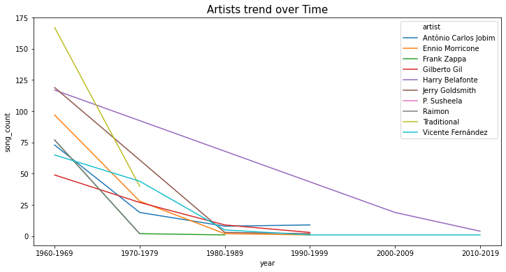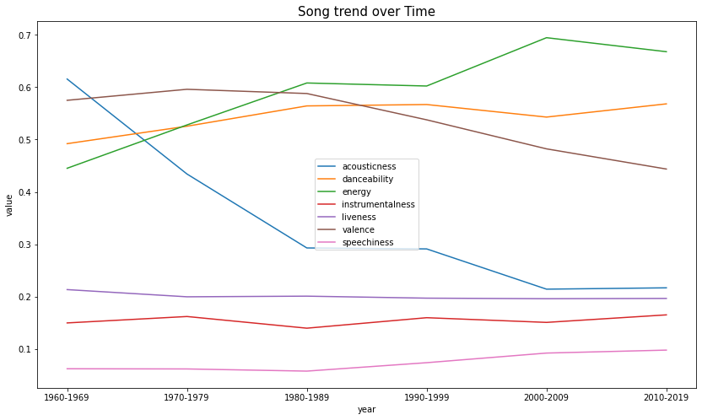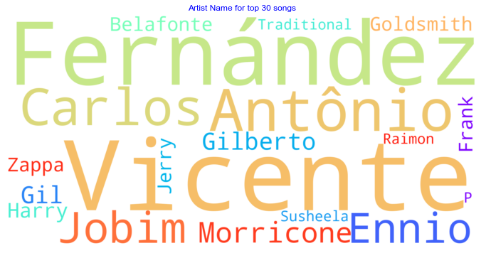

Thank you:

Abhishek .J.N

[abhishekwithu101@gmail.com](mailto:abhishekwithu101@gmail.com)